|  |  |  |  |  |  |  |  |  |  |  |  |  |  |  |  |
| --- | --- | --- | --- | --- | --- | --- | --- | --- | --- | --- | --- | --- | --- | --- | --- |
| **Infy Medicals Store**  **Class-Diagram**  **erlogo_transp**  **Education & Research Department**  **© Infosys Technologies Ltd**  infosyslogosmall   |  |  |  |  |  | | --- | --- | --- | --- | --- | | **VersionRevision** | **Date** | **Authors** | **Reviewed by** | **Description** | | 1.00 | 22 Apr, 2010 | Ashwini K J | Ashwini K J | Intial Write | | 2.00 | 1 Jun 2010 | Ashwini K J |  | Updated | |

|  |
| --- |
|  |

COPYRIGHT NOTICE

*All ideas and information contained in this document are the intellectual property of Education and Research Department, Infosys Technologies Limited. This document is not for general distribution and is meant for use only for the person they are specifically issued to. This document shall not be loaned to anyone, within or outside Infosys, including its customers. Copying or unauthorized distribution of this document, in any form or means including electronic, mechanical, photocopying or otherwise is illegal.*

Education and Research Department

Infosys Technologies Limited

Electronic City

Hosur Road

Bangalore - 561 229, India.

Tel: 91 80 852 0261-270

Fax: 91 80 852 0362

[www.infy.com](http://www.infy.com/)

<mailto:E&R@infy.com>

*Table Of Contents*

COPYRIGHT NOTICE 2

1. Class Diagrams 4

1.1. Entity Beans 4

1.1.1 BlockedCardEntity 4

1.1.2 CardEntity 5

1.1.3 CustomerEntity 6

1.1.4 SchemeEntity 7

1.1.5 TransactionEntity 7

1.1.6 PaymentEntity 8

1.1.7 LoginEntity 8

1.1.8 CardApplicationEntity 9

1.2 Managed Beans 9

1.2.1 BlockedCardMB 9

1.2.2 CardApplicationMB 10

1.2.3 CardUsageMB 11

1.2.4 PaymentMB 12

1.2.5 TransactionMB 13

1.2.6 UnblockCardMB 13

1.2.7 ViewCardDetailsMB 14

1.2.8 CardMB 15

1.2.9 CustomerMB 16

1.2.10 SchemeMB 17

1.2.11 LoginMB 17

1.2.12 BlockStatisticsMB 17

1.2.13 RevenueStatisticsMB 18

1.2.14 SchemeReportMB 19

1.2.15 CardStatusMB 20

1.2.16 TransactionStatisticsMB 21

1.3 Service Class 21

1.3.1 CardService 22

1.3.2 SchemeService 22

1.3.3 PaymentService 22

1.3.4 CustomerService 22

1.3.5 LoginService 22

1.3.6 TransactionService 22

1.3.7 ReportService 23

1.4 Manager Class 23

1.4.1 ReportManager 23

1.4.2 CardManager 23

1.4.3 CustomerManager 24

1.4.4 PaymentManager 24

1.4.5 SchemeManager 24

1.4.6 TransactionManager 24

1.4.7 LoginManager 24

1.5 Wrapper Class 24

1.5.1 InfyCreditCardWrapper 24

1.6 Transfer Objects 25

1.5.1 BlockedCardTO 26

1.5.2 CardApplicationTO 26

1.5.3 CardTO 27

1.5.4 LoginTO 27

1.5.5 TransactionTO 28

1.5.6 SchemeTO 28

1.5.7 CustomerTO 29

1.5.8 PaymentTO 29

1.5.9 ApprovedCardTO 30

# Class Diagrams

## Entity Beans

The class diagrams for the Entity Beans used in this application are given below.

### BlockedCardEntity

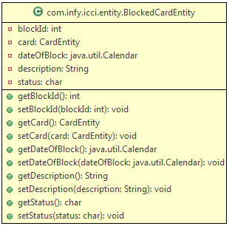

### CardEntity

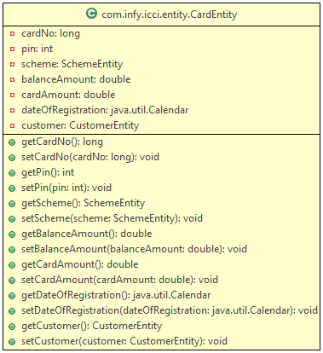

### 1.1.3 CustomerEntity

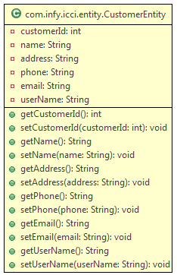

### 1.1.4 SchemeEntity

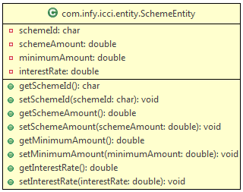

### 1.1.5 TransactionEntity

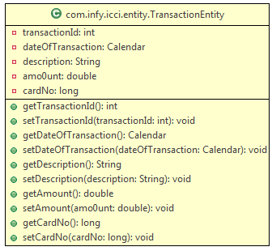

### 1.1.6 PaymentEntity

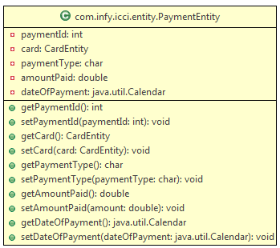

### 1.1.7 LoginEntity

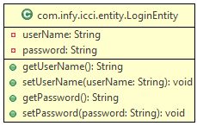

### CardApplicationEntity

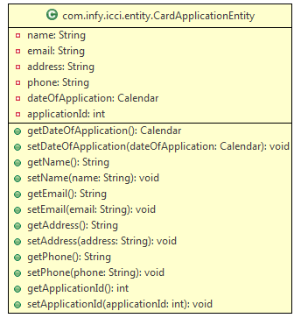

## 1.2 Managed Beans

The class diagrams for the Managed Beans used in this application are given below.

### BlockedCardMB

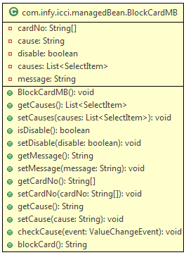

### CardApplicationMB

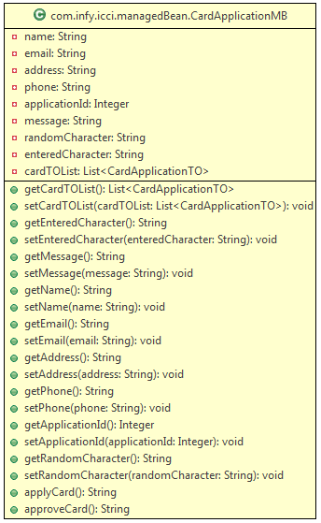

### CardUsageMB

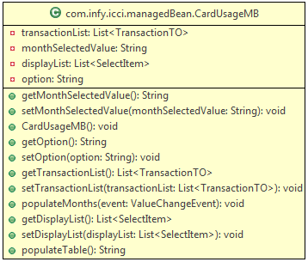

### PaymentMB

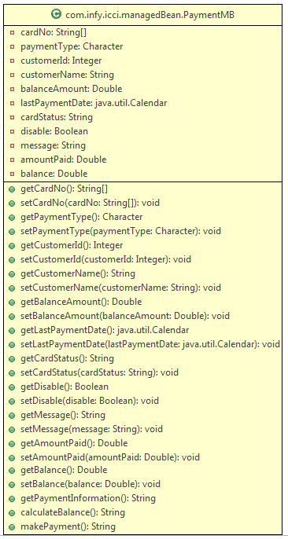

### TransactionMB

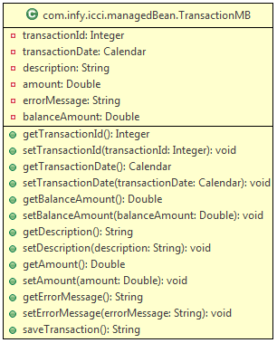

### UnblockCardMB

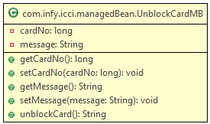

### ViewCardDetailsMB

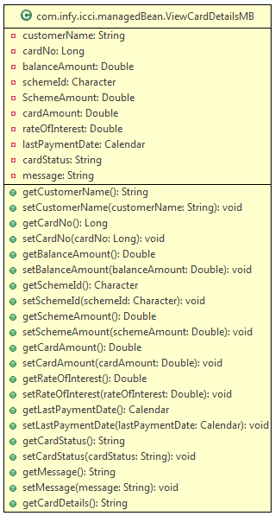

### CardMB

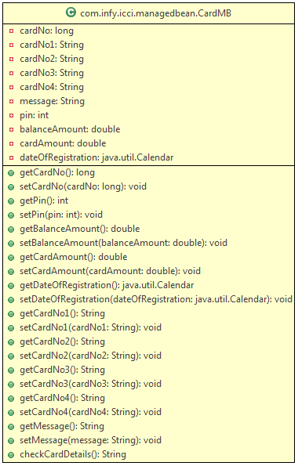

### CustomerMB

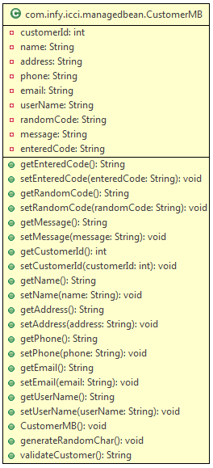

### SchemeMB

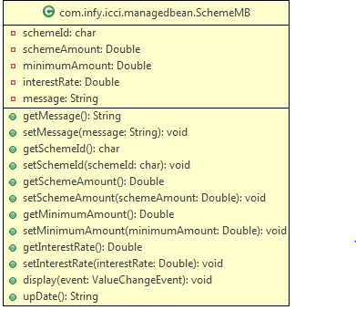

### 1.2.11 LoginMB

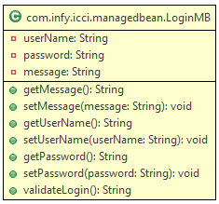

### 1.2.12 BlockStatisticsMB

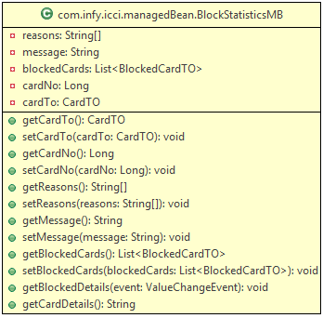

### 1.2.13 RevenueStatisticsMB

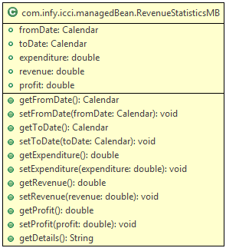

### 1.2.14 SchemeReportMB

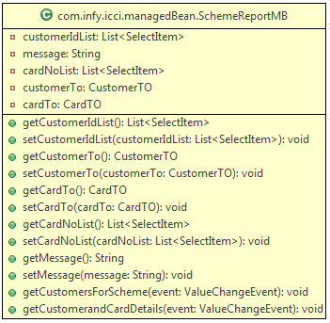

### 1.2.15 CardStatusMB

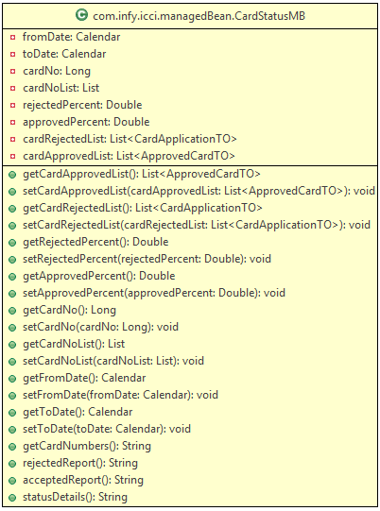

### 1.2.16 TransactionStatisticsMB

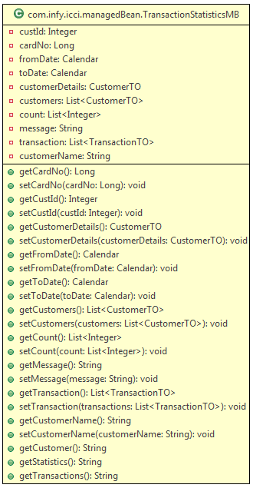

## 1.3 Service Class

The class diagrams for the Service classes used in this application are given below

### CardService

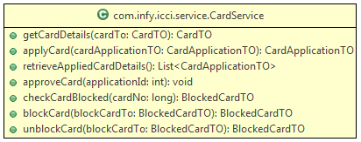

### SchemeService

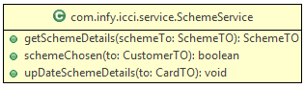

### PaymentService

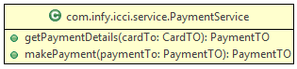

### CustomerService

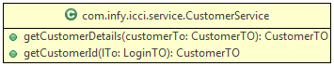

### LoginService



### TransactionService

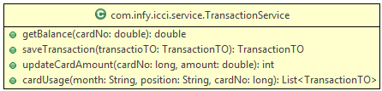

### ReportService

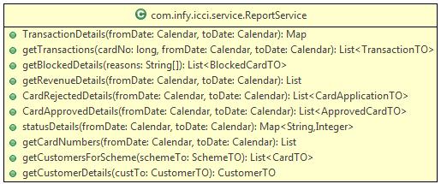

## 1.4 Manager Class

The class diagrams for the Manager Classes used in this application are given below

### ReportManager

**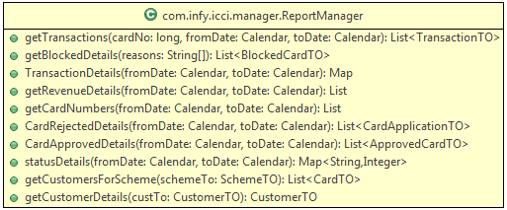**

### CardManager

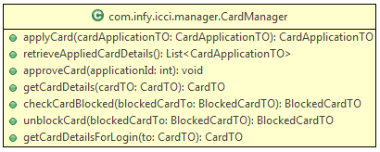

### CustomerManager

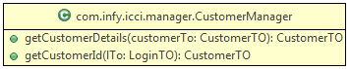

### PaymentManager

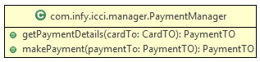

### SchemeManager

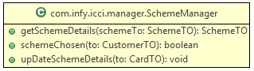

### TransactionManager

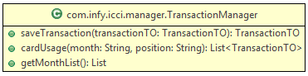

### LoginManager



## 1.5 Wrapper Class

The class diagrams for the wrapper class used in this application are given below

### InfyCreditCardWrapper

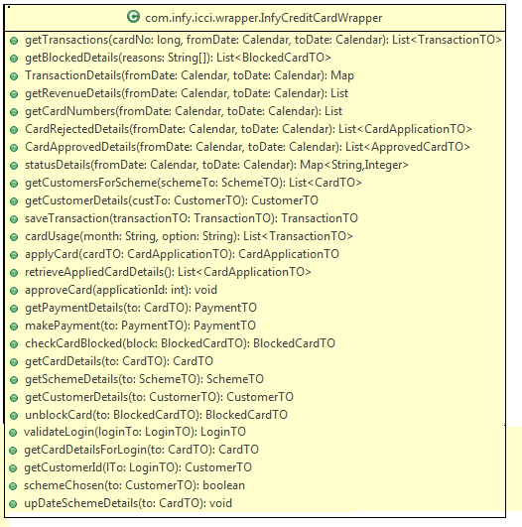

## 1.6 Transfer Objects

The class diagrams for the transfer objects used in this application are given below

### BlockedCardTO

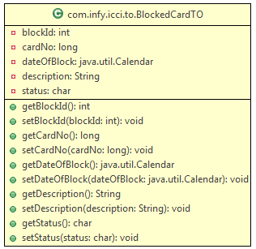

### CardApplicationTO

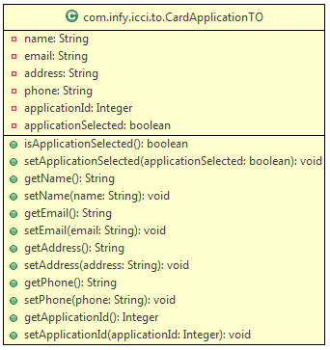

### CardTO

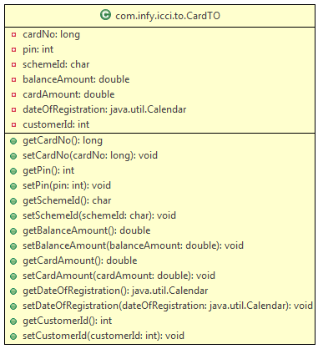

### LoginTO

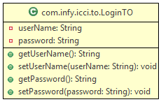

### TransactionTO

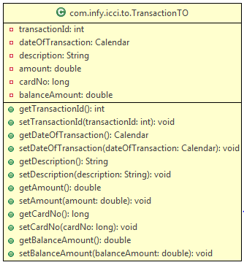

### SchemeTO

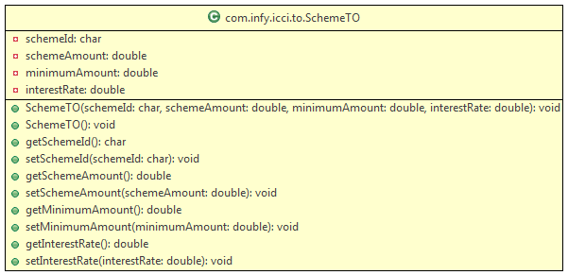

### CustomerTO

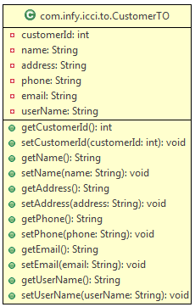

### PaymentTO

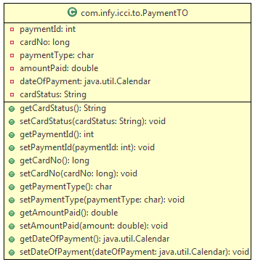

### ApprovedCardTO

